S  A

U N I V E R S I T Y

**Subject**

Programming and data structures using C

**Assignment 3**

**Submitted by: Submitted to:**

**Ankeeta Kumari Prof. M.Thangavel**

**MCA (Group-1) CSE, ITER, SOA**

**Write a C Program for the following problem statements:-**

1. **Display multiple variables.**

**Sample Variables:**

**a + c, x + c, dx + x, a + x, s + b, ax + b, s + c, ax + c, ax + ux**

**Declaration: int a = 125, b = 12345;**

**long ax = 1234567890;**

**short s = 4043;**

**float x = 2.13459;**

**double dx = 1.1415927;**

**char c = 'W';**

**unsigned long ux = 2541567890;**

**Ans:** #include <stdio.h>

int main()

{

int a = 125, b = 12345;

long ax = 1234567890;

short s = 4043;

float x = 2.13459;

double dx = 1.1415927;

char c = 'W';

unsigned long ux = 2541567890;

printf("a+b = %d",a+b);

printf("\na+c = %d ==> letter will be converted in to ASCII and sum with integer.",a+c);

printf("\nx+c = %f",x+c);

printf("\ndx+x = %lf",dx+x);

printf("\na+x = %f",a+x);

printf("\ns+b = %i",s+b);

printf("\nax+b = %li",ax+b);

printf("\ns+c = %i",s+c);

printf("\nax+c = %li",ax+c);

printf("\nax+ux = %li",ax+ux);

return 0;

}

**OUTPUT:**

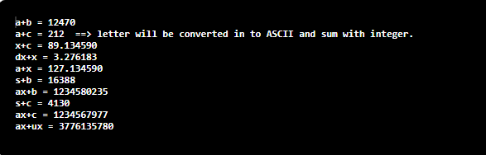

1. **Convert specified days into years, weeks and days.**

**Ans:** #include <stdio.h>  
  
int main()  
{  
    int d,y,w,d1;  
    printf("Enter the Days:");  
    scanf("%d",&d);  
     
    y=d/365;  
    w=(d-(y*365))/7;  
    d1=(d-((y*365)+(w*7)));  
    printf("y:%d , w: %d , d: %d ",y,w,d1);  
  
    return 0;  
}

**OUTPUT:**

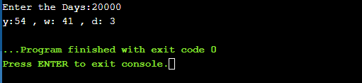

1. **Accepts two item’s weight (floating points' values) and number of purchase (floating points' values) and calculate the average value of the items.**

**Ans:** #include <stdio.h>

float main()

{

float w1, w2, c1, c2, avg;

printf("Enter the Weight1:");

scanf("%f",&w1);

printf("Enter the Weight2:");

scanf("%f",&w2);

printf("Enter the number of purchased item of Weight1:");

scanf("%f",&c1);

printf("Enter the number of purchased item of Weight2:");

scanf("%f",&c2);

avg =((w1*c1)+(w2*c2))/(c1+c2);

printf("\nAverage Value = %f\n", avg);

return 0;

}

**OUTPUT:**

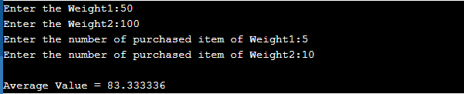

**4. Create enumerated data type for 7 days and display their values in integer constants.**

**Ans:** #include <stdio.h>

int main()

{

enum week{sun,mon,tue,wed,thur,fri,sat};

printf("sun=%d",sun);

printf("\n mon=%d",mon);

printf("\n tue=%d",tue);

printf("\n wed=%d",wed);

printf("\n thur=%d",thur);

printf("\n fri=%d",fri);

printf("\n sat=%d",sat);

}

**OUTPUT:**

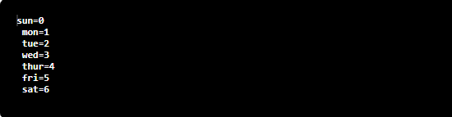

1. **Convert Centigrade to Fahrenheit.**

**Ans:** #include <stdio.h>  
 float main()  
{  
   
float f;  
printf("Enter the Fahrenheit degree ");  
scanf("%f",&f);  
f=(f-32)*5/9;  
printf("The  Centigrade value of given Fahrenheit degree is \n %.2f Degree",f);  
    return 0;  
}

**OUTPUT:**

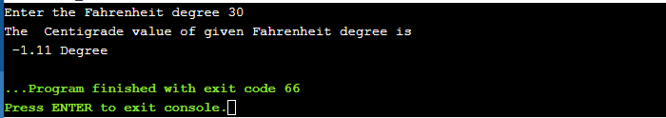

1. **Takes minutes as input, and display the total number of hours and minutes.**

**Ans:** #include <stdio.h>  
  
float main()  
{  
 int m,h;  
printf("Enter the Minutes : ");  
scanf("%d",&m);  
h=m/60;  
m=(m-h*60);  
printf("h: %d, m: %d  ",h,m);  
    return 0;  
}

**OUTPUT:**

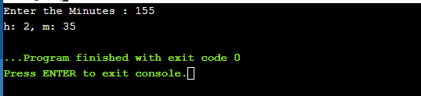

1. **Prints the perimeter of a rectangle to take its height and width as input.**

**Ans:** #include <stdio.h>

float main()

{

int h, w,p;

printf("Enter the height of rectangle:");

scanf("%d",&h);

printf("Enter the width of rectangle:");

scanf("%d",&w);

p=2*(h+w);

printf("The perimeter of rectangle is %d",p);

return 0;

}

**OUTPUT:**

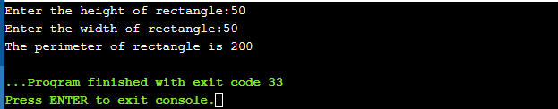

1. **By using +, /, %=, >=, ! operators.**

**Ans:** #include <stdio.h>

int main()

{

int a = 9,b = 3, c;

c = a+b;

printf("a+b = %d \n",c);

c = a/b;

printf("a/b = %d \n",c);

c %= a;

printf("c = %d\n", c);

printf("%d >= %d is %d \n", a, b, a >= b);

c = !(a == b);

printf("!(a == b) is %d \n", c);

return 0;

}

**OUTPUT:**

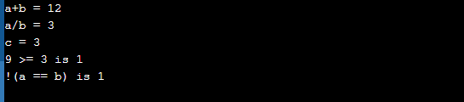

1. **By using &, |, >>, ?:, || operators.**

**Ans:** #include <stdio.h>

int main()

{

int a=9,b=3,c=5,d,num=212,i;

printf("Output = %d\n", a&b);

printf("Output = %d\n", a|b);

for (i=0; i<=2; ++i)

printf("Right shift by %d: %d\n", i, num>>i);

d=((a==5)?(3):(2));

printf("The value of 'b' variable is : %d\n",b);

d=(a == b) || (c < b);

printf("(a == b) || (c < b) is %d \n",d);

return 0;

}

**OUTPUT:**

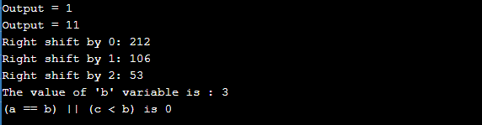

1. **Find the Size of int, float, double and char.**

**Ans:** #include <stdio.h>  
  
int main()  
{  
   
printf("Size of Int is %lu Bytes\n",sizeof(int));  
printf("size of Float is %lu Bytes\n",sizeof(float));  
printf("size of Double is %lu Bytes\n",sizeof(double));  
printf("size of Char is %lu Bytes\n",sizeof(char));  
  
    return 0;  
}

**OUTPUT:**

